Routing and backflush setup

QAD EE 2016

Table of Contents
Objective 3
Process Steps 3
Employee Create/ Employee Modify: 36.1.7.1 / 36.1.7.2 3
Department Maintenance: 14.1 4
Work Center Maintenance: 14.5 4
Standard Operation Maintenance: 14.9 5
Routing Maintenance: 14.13.1 6
Item Planning Maintenance: 1.4.7/ 1.4.17 for multi-site - IMPORTANT 6
Production line maintenance: 18.22.1.1 - IMPORTANT 7
Manual backflush transaction: 18.22.13 8

Objective

In order to successfully complete backflush transaction several setup steps need to be made.

Process Steps

To perform backflush it is required to create Employee and Department.

Employee Create/ Employee Modify: 36.1.7.1 / 36.1.7.2

Here it is enough to create only one employee. No other fields are required to be filled.
Should be created already by G2 team
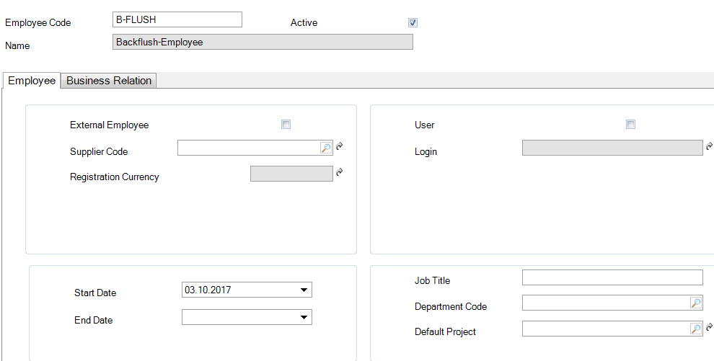

Department Maintenance: 14.1
Here it is enough to create one department for BF only. No other fields are required to be filled.
Should be created already by G2 team

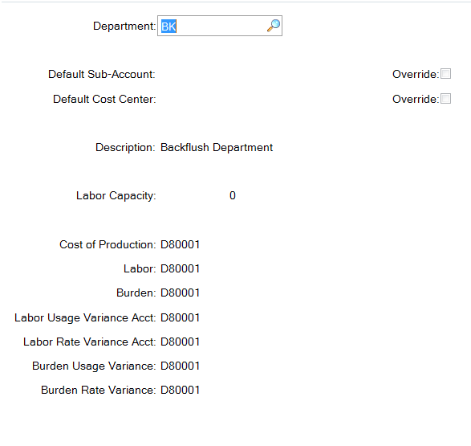

Work Center Maintenance: 14.5

For backflush separate work center has to be created: BK
To this work center you need to link previously created Department (14.1)
Should be created already by G2 team

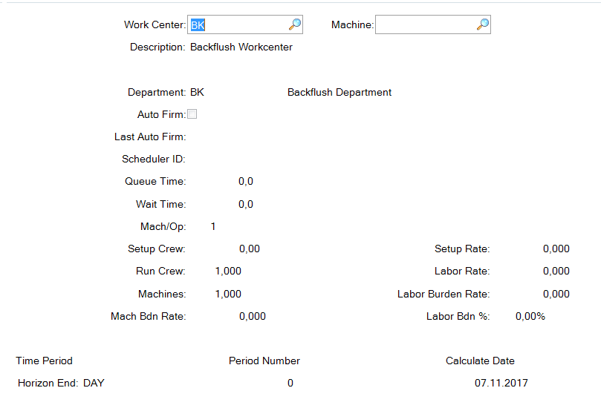

Standard Operation Maintenance: 14.9

One standard operation must be created in the system with code 999.
It must me setup as 100% Yield Percentage and checked as Milestone Operation.
Also previously created Work Center has to be linked to 999 operation
Should be created already by G2 team
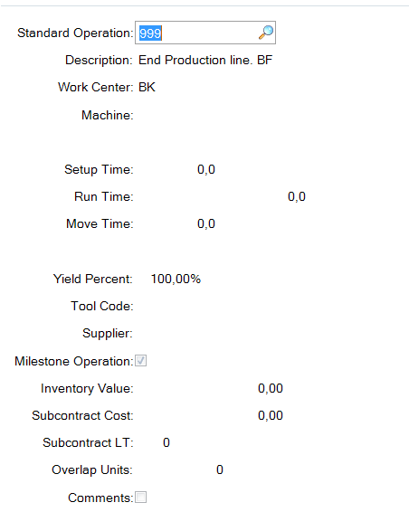

Routing Maintenance: 14.13.1

When creating default routing following data should be setup:
- Standard Operation should be assigned
- Work Center should be assigned
- Milestone Operation should be checked
- Yield Percent should be set 100%
Should be created already by G2 team
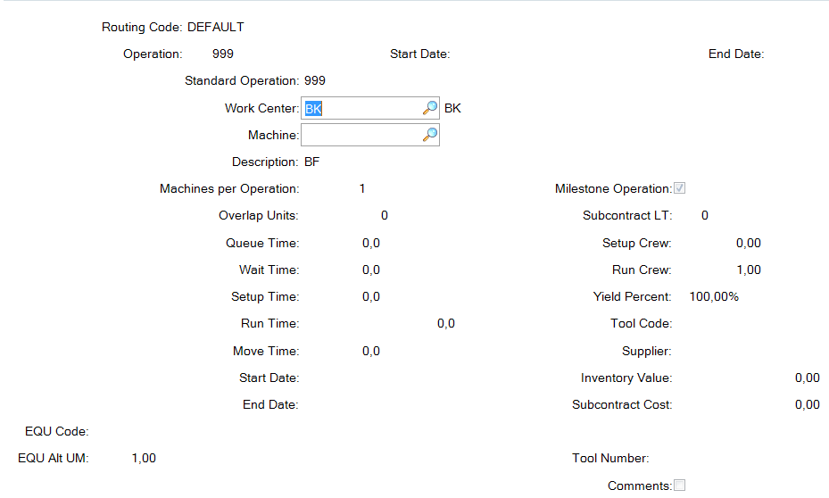

Item Planning Maintenance: 1.4.7/ 1.4.17 for multi-site - IMPORTANT

The most important parameters here to setup are:
- Routing Code (NEW Requirement) – must be assigned to each part that is being produced.
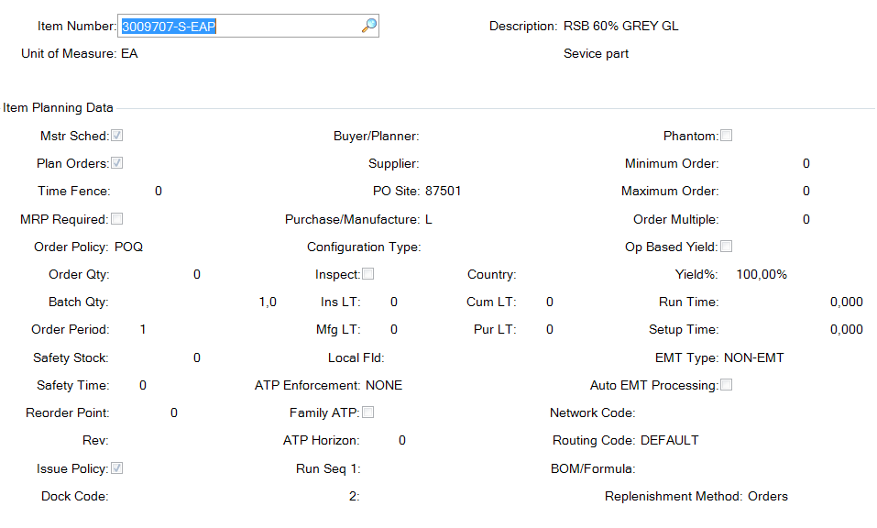

Production line maintenance: 18.22.1.1 - IMPORTANT
All manufactured parts must be assigned to production line via 18.22.1.1 program.

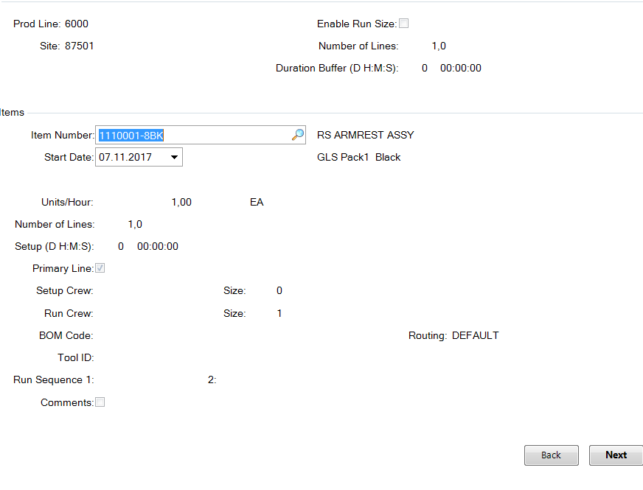

Manual backflush transaction: 18.22.13

When you do manual backflush in QAD EE 2016 following data must be entered:
- Employee: created on previous step
- Site: choose relevant site for this part
- Item number: Item that you want to backflush
- Standard operation: created on previous step
- Routing code (default): created on previous step
- Location (default): location to which manufactured part will be received
- Work center (default): created on previous step
- Qty processed: how many pieces you want to backflush
